2. A bank demands near-zero downtime, making a full or partial mesh topology the right choice. In a full mesh, every core network device — routers, core switches, and servers — connects directly to every other device, so no single link or node failure can bring down the network. For a bank, a partial mesh is typically deployed at the core layer (connecting all core switches and firewalls to each other) while the distribution and access layers use redundant uplinks to at least two core switches. Dual enterprise-grade routers (such as Cisco ASR or Juniper MX series) provide BGP-based redundant internet connectivity. All links between core devices use fiber optic cables — either single-mode for long distances between buildings or multi-mode OM4 within the data center — because fiber is immune to electromagnetic interference, supports very high bandwidth, and is essential for maintaining low-latency financial transactions. Redundant power supplies, UPS systems, and RAID storage arrays further complement the mesh design. The justification is straightforward: when a link fails in a mesh, traffic automatically reroutes through alternative paths in milliseconds using protocols like OSPF or BGP, satisfying regulatory requirements for uptime and data integrity.

AIM :
To design and implement a low-cost classroom computer network using Bus Topology, where multiple computers share a common communication backbone, and to simulate network communication, collisions, file sharing, and backbone failure using HTML, CSS, and JavaScript.

OBJECTIVES
- To understand the working principle of Bus Topology.
- To design a network where multiple computers share a single backbone cable.
- To simulate the use of T-connectors and 50Ω terminators in a coaxial bus network.
- To demonstrate data collisions when multiple computers communicate over the shared medium.
- To simulate backbone cable failure and observe its effect on all connected computers.
- To demonstrate file sharing using a Teacher PC without requiring a dedicated server.
- To develop an interactive and low-cost network simulation suitable for a small classroom laboratory.
- To understand the advantages and limitations of Bus Topology.

CODE IMPLEMENTATION
1. Creating the Bus Backbone
<div id="backbone" class="backbone">
<div class="computer" id="PC1">
<div class="computer-icon"></div>
<b>Student PC 1</b>
<small>Room A</small>
</div>
<div class="computer" id="PC2">
<div class="computer-icon"></div>
<b>Student PC 2</b>
<small>Room A</small>
</div>

</div>

EXPLANATION
This section creates the common backbone and the computers connected to it.
- backbone represents the main communication cable.
- PC1, PC2, etc. represent individual student computers.
- All computers are connected to the same backbone, representing Bus Topology.

2. Designing the Backbone

.backbone {
width: 100%;
height: 12px;

background:
linear-gradient(
90deg,
#53d85a,
#c2df58,
#53d85a
);

box-shadow:
0 0 18px
rgba(87,216,90,.7);

border-radius: 10px;
}
EXPLANATION :
This CSS creates the visual representation of the bus cable.
- width: 100% makes the backbone extend across the network.
- height: 12px gives thickness to the cable.
- background gives the cable a green appearance.
- box-shadow creates a glowing effect.
- border-radius makes the cable look smooth.
3. Collision Simulation

let collisions = 0;

function simulateCollision() {

if (networkFailed) {
return;
}

collisions++;

document.getElementById(
"collisionCount"
).innerText = collisions;

addLog(
"Collision detected on shared bus.",
"warning"
);

setTimeout(() => {

addLog(
"CSMA/CD waiting and retransmission initiated.",
"warning"
);

}, 700);

setTimeout(() => {

addLog(
"Transmission successful after retransmission.",
"success"
);

}, 1400);
}

EXPLANATION :
- collisions++ increases the collision count.
- addLog() displays the event.
- setTimeout() creates a delay between the events.
- The final message indicates successful retransmission.

EXECUTED OUTPUT :

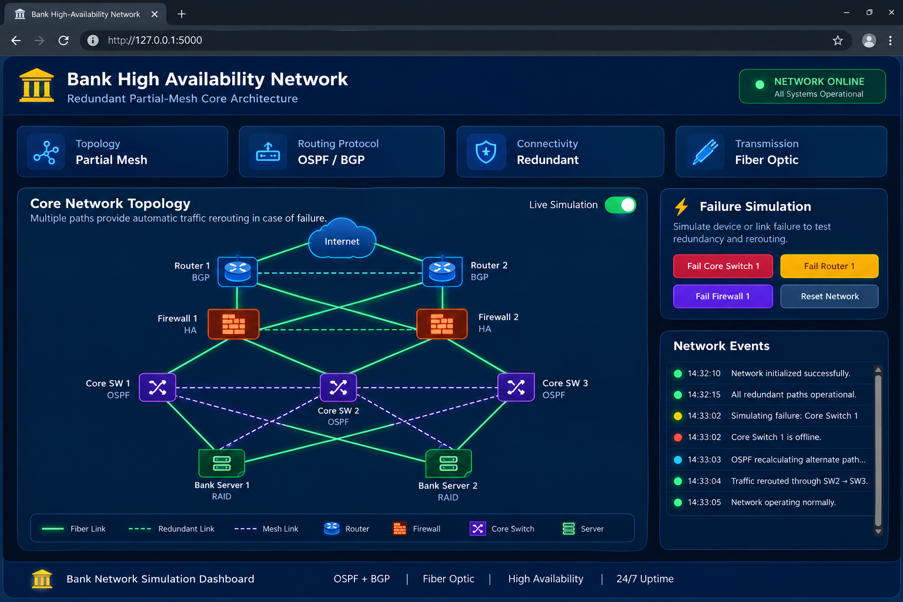

- The output displays an interactive Classroom Bus Network Simulator developed using HTML, CSS, and JavaScript.
- The application shows a classroom network in which eight student computers and a Teacher PC communicate through a common bus backbone.

1. Network Status
- At the top of the application, the status is displayed as:
NETWORK ONLINE
- This indicates that the backbone is functioning and all connected computers can communicate.

2. Network Topology
- The center of the screen displays the Bus Topology.
- All student computers are connected to a single common backbone cable. The two ends of the cable contain 50Ω terminators, which represent the traditional coaxial bus configuration.
- The displayed components include:
- Student PC 1 to Student PC 8
- Common bus backbone
- T-connectors
- 50Ω terminators
- Teacher PC

3. Network Information
- The dashboard displays important network characteristics:
- Topology: BUS
- Backbone: COAXIAL
- Cost: LOW
- Server: TEACHER PC

